

**ASSIGNMENT COVER PAGE**

**Please fill in all the required details for your assignment to be accepted.**

|  |  |  |  |
| --- | --- | --- | --- |
| Student’s Name | PAUL ZIPPORAH OCHANYA | | |
| Student’s Matric No | 0102303133 | | |
| Year/Semester | Final Year | | |
| Program | Computer Science (Cyber Security & Network Technology) | | |
| Subject Name / Subject Code | LNXA 371 | | |
| Lecturer’s Name | MR JAFAR | | |
| Assignment Title | Linux Administration | | |
| No. of Page (excluding this page) |  | | |
| Required words |  | Actual of words |  |
| Soft copy included | Yes / No | | |
| **DECLARATION BY STUDENTS:**  *I certify that this assignment is my own work in my own words. All resources have been acknowledged and the content has not been previously submitted for assessment to LINCOLN or elsewhere. I also confirm that I have kept a copy of this assignment.*  Sign: Zipporah Date: 8/9/2025 | | | |

Linux Administration Tasks.

# ASSIGNMENT

1. Write a bash script to create 5 new users, add them to a group ‘devteam’, set their password and force them to change password on first login.

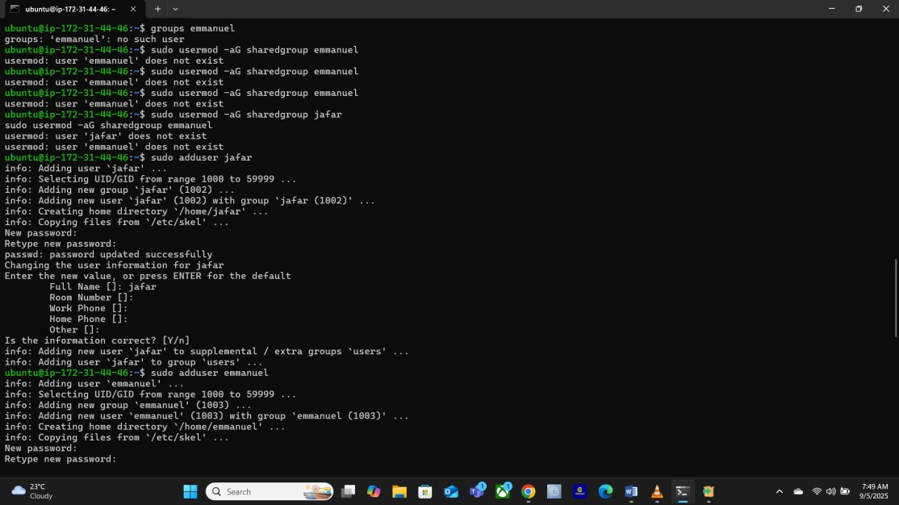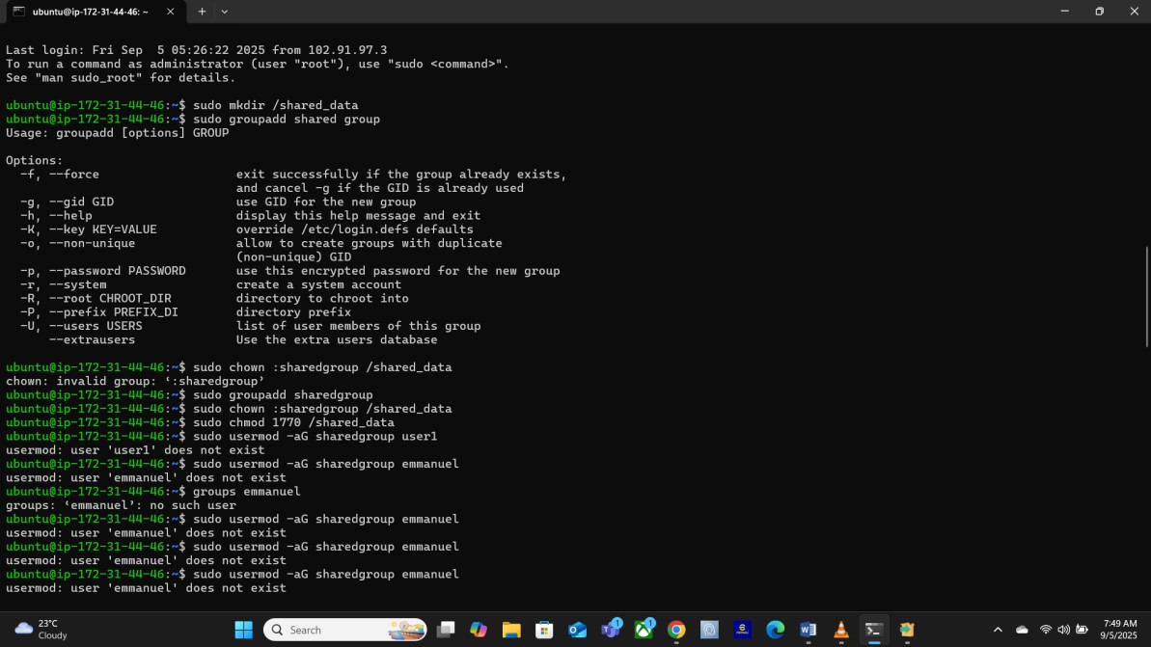

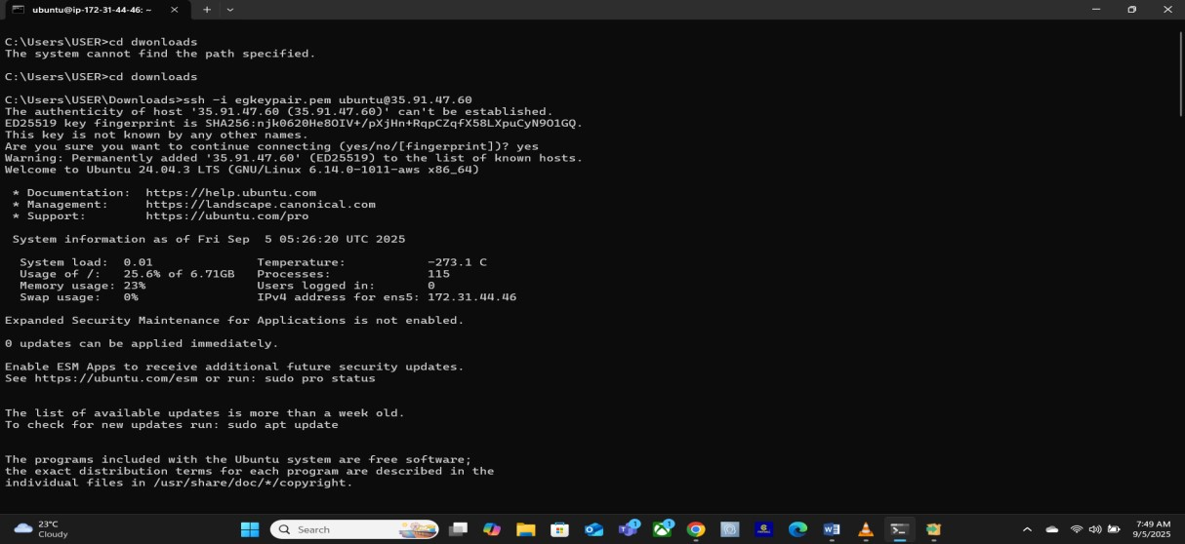

1. Create a shared directory ‘/shared data’ where group members can read/write but not delete others’ files. Use ACL to grant read-only access to one extra user outside the group.

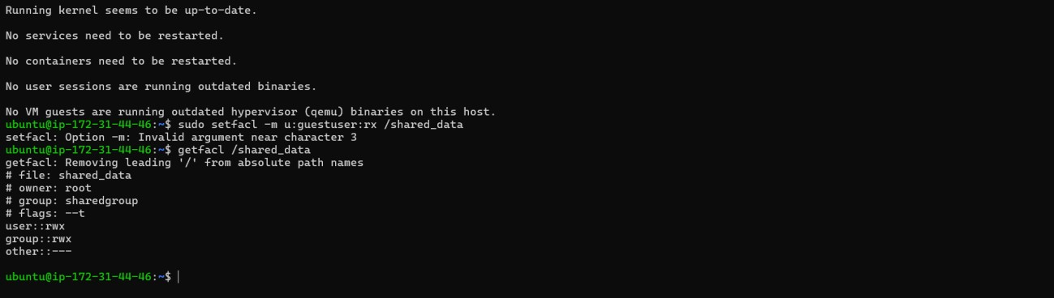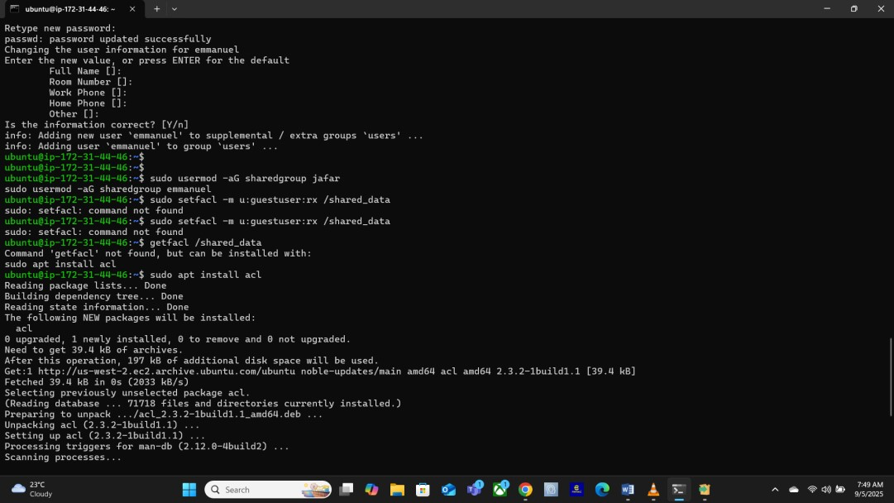

1. Configure Apache to host two websites (‘site.local’, ‘site2.local’) with separate documents roots and logs.

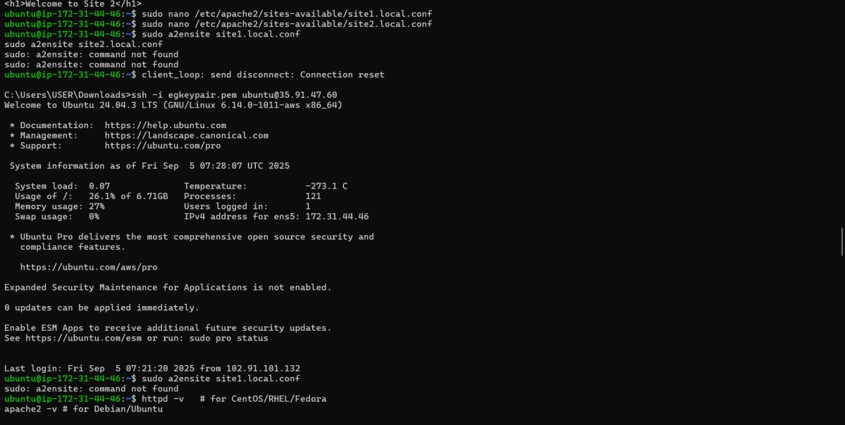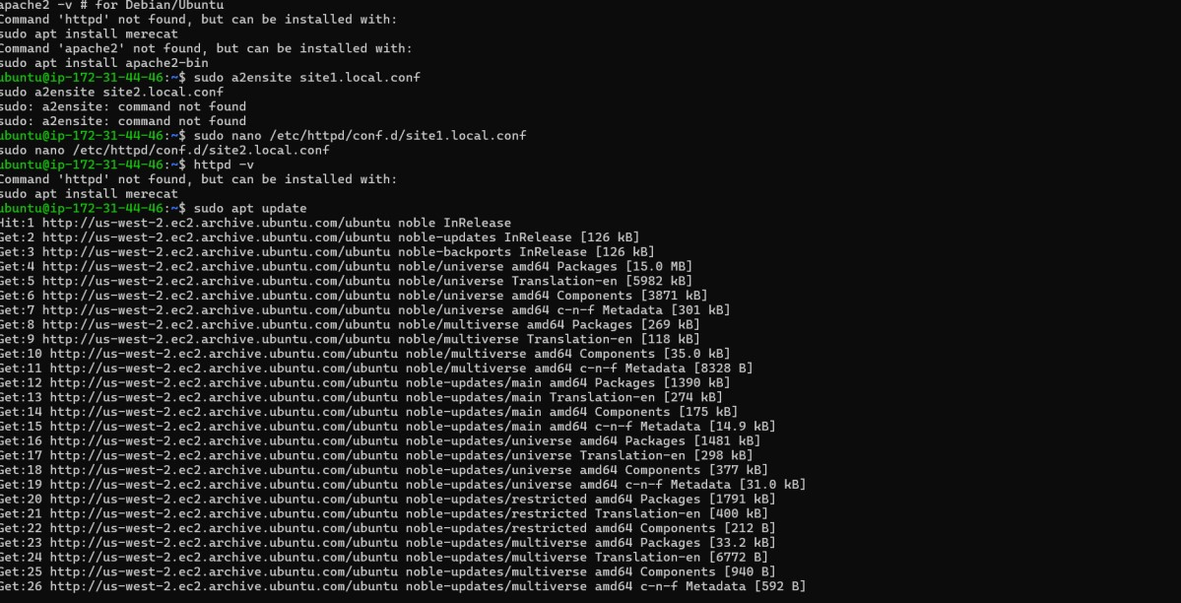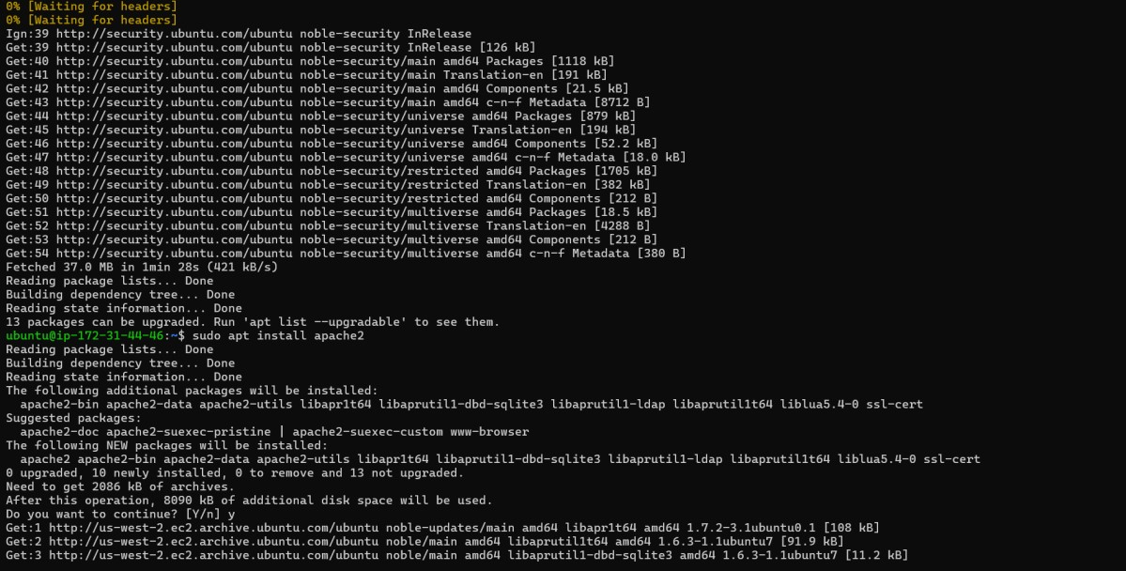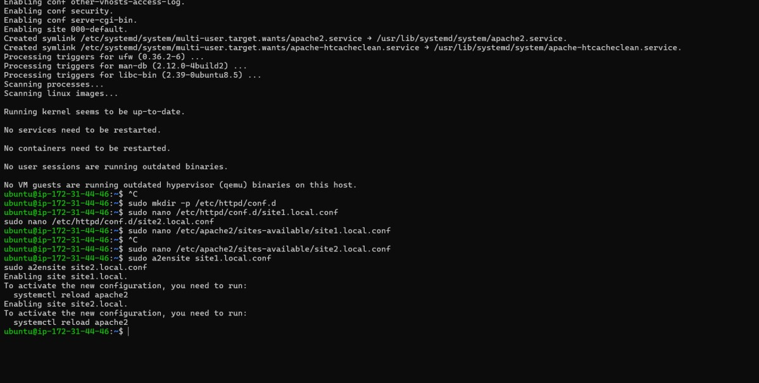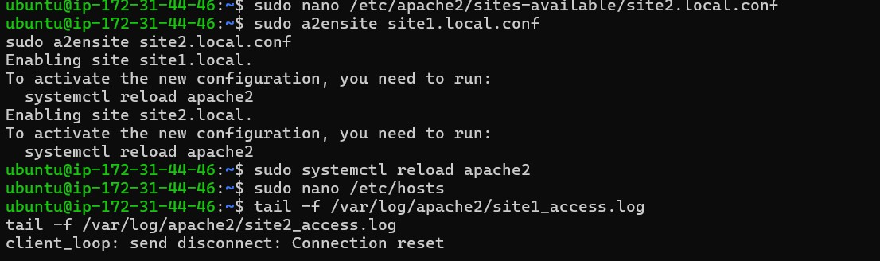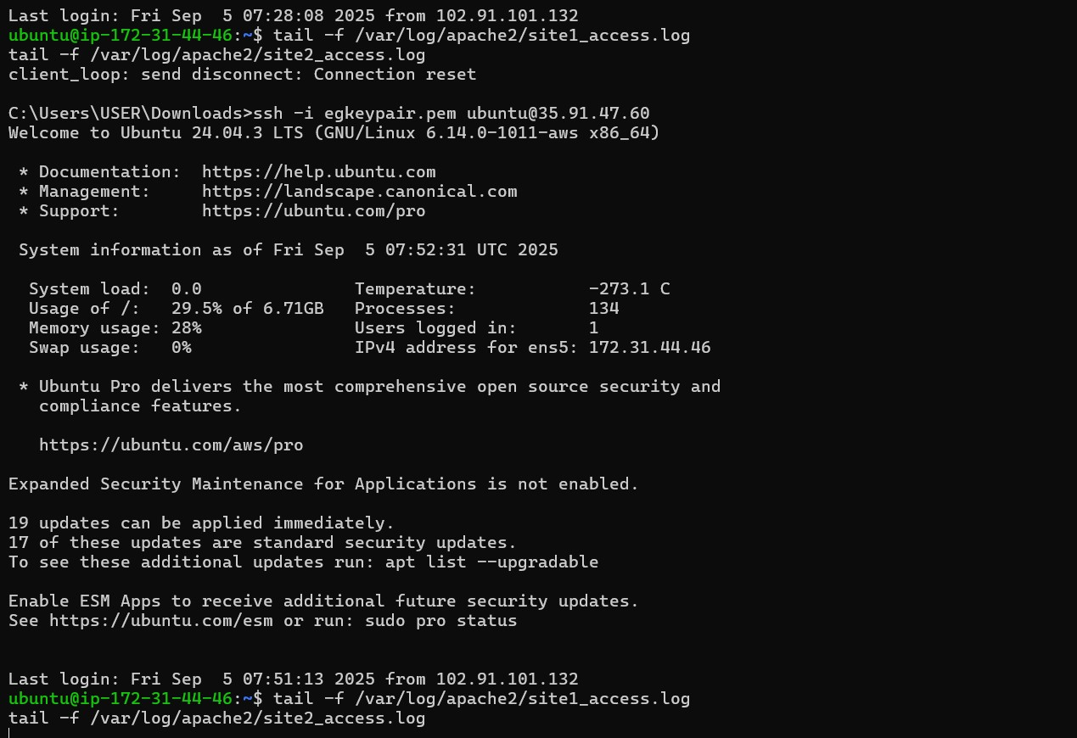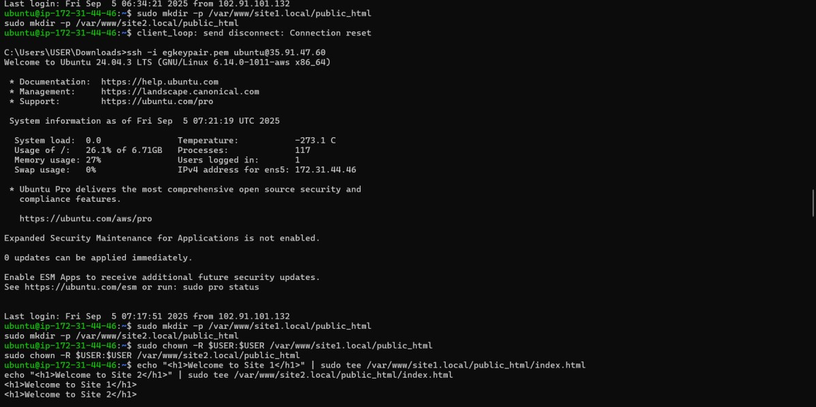

1. Generate a self-signed SSL certificate using ‘openssl’ and enable HTTPS for one of your virtual hosts.

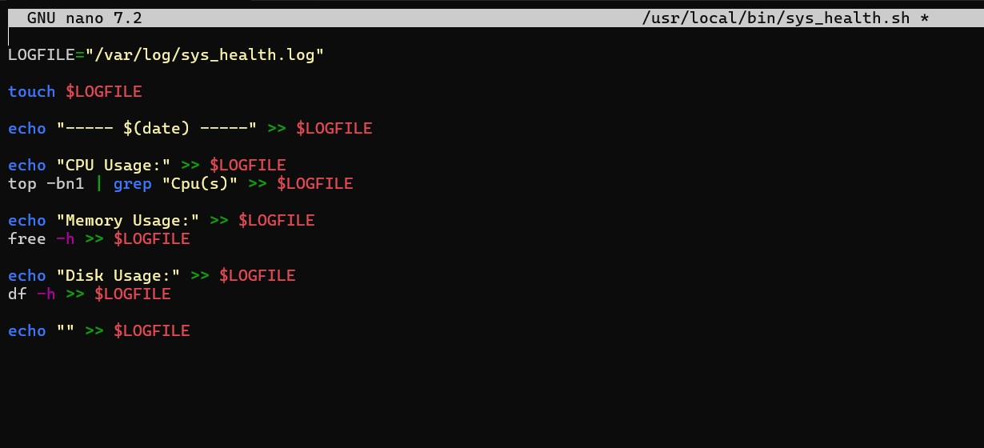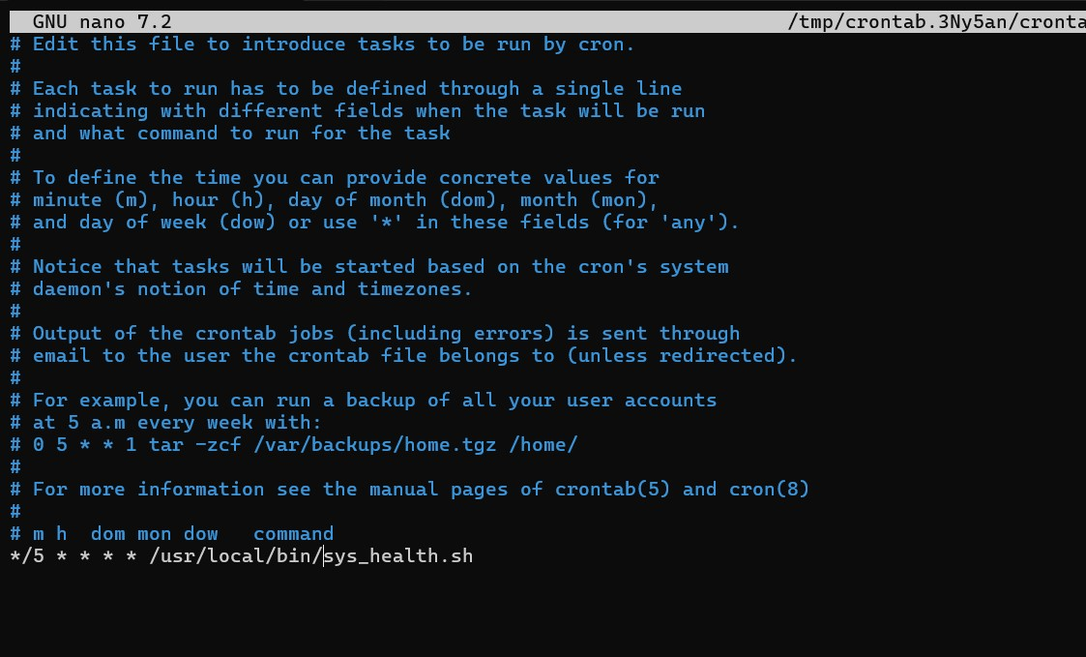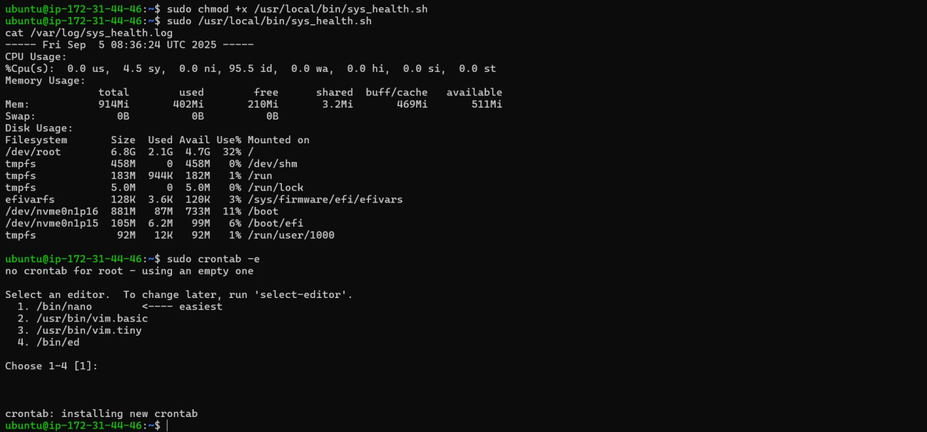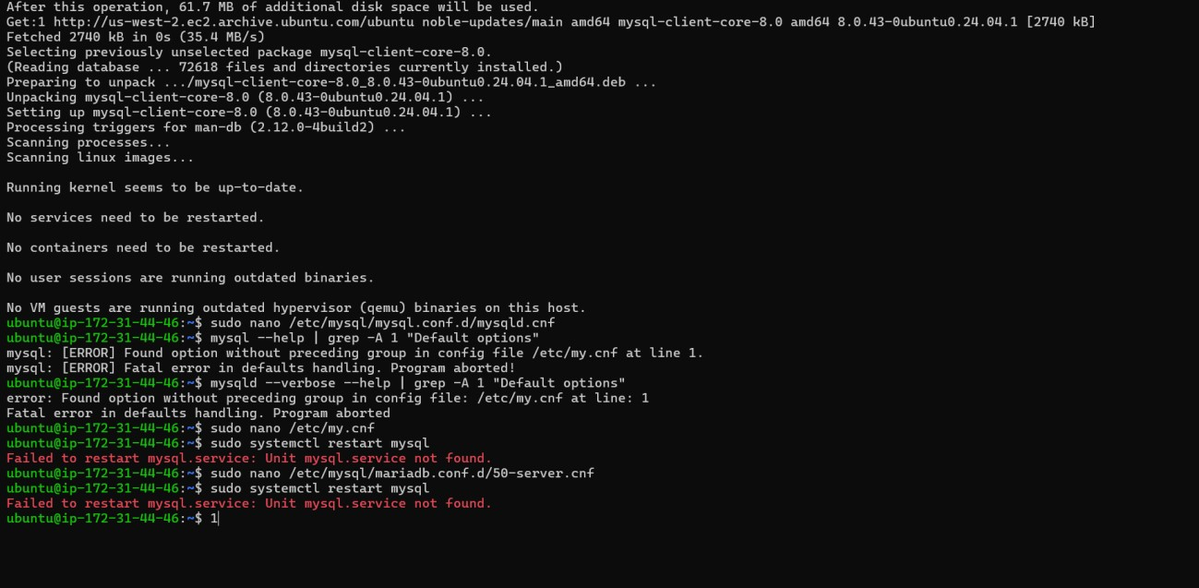

1. Configure MYSQL to allow secure remote connections, create a database and user with least priviliege for remote access.

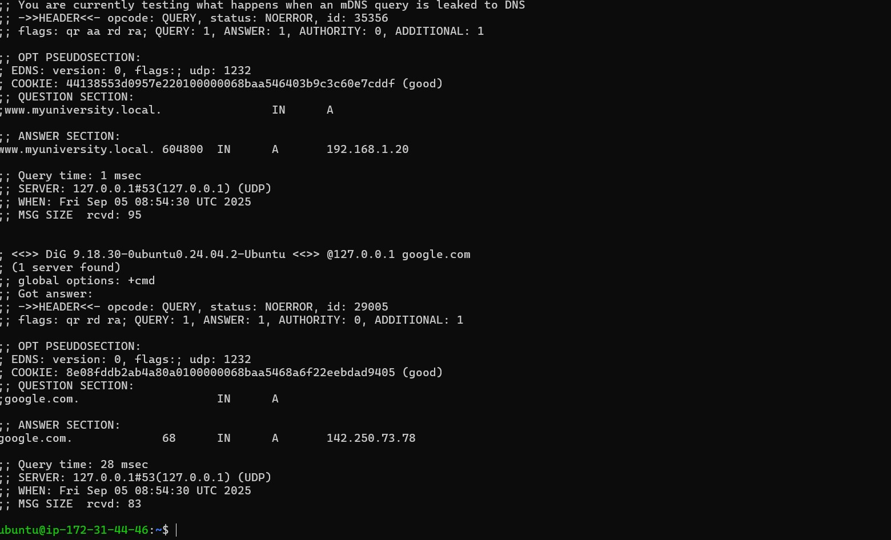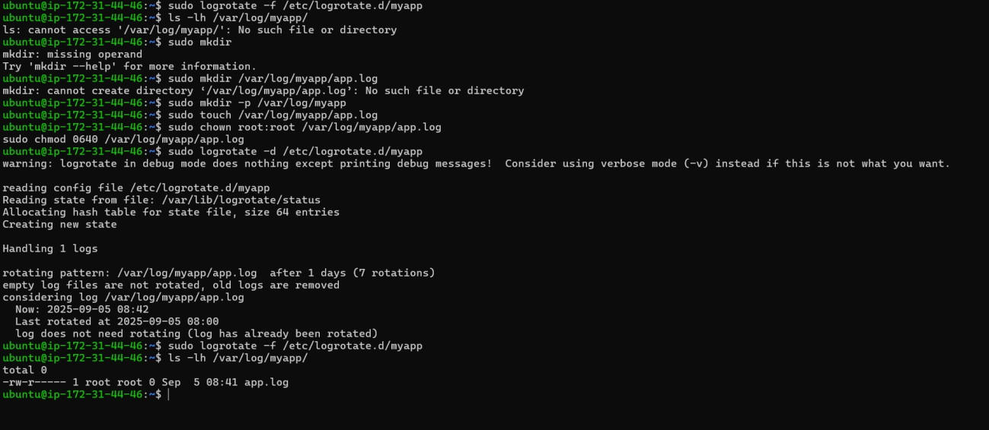

1. Configure ‘ufw’ or’iptables’ to allow only HTTP(80), HTTPS(443), SSH(22), and MySQL(3306) from a specific IP range.

1. Write a script to log CPU, Memory, and Disk usage every 5 minutes into ‘/var/log/sys_health.log’ and set as a cron job



1. Configure ‘logrotate’ for a custom application log to rotate daily, compress olsd logs and keep only 7 days.

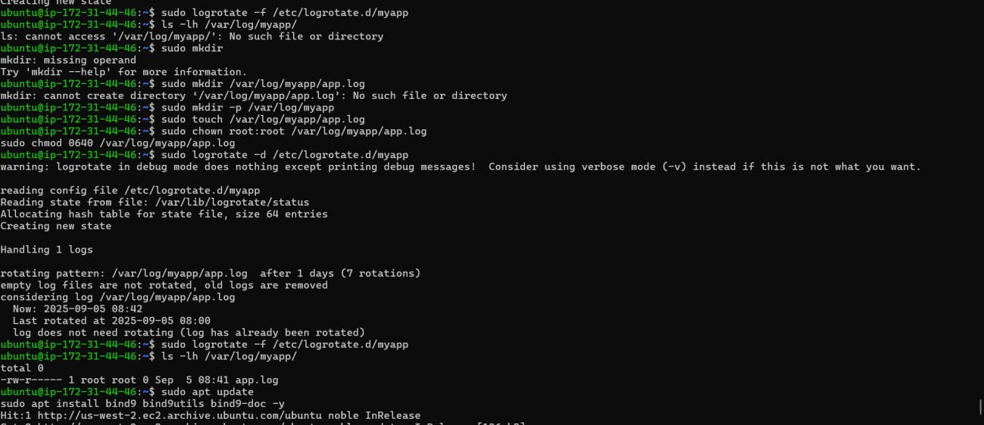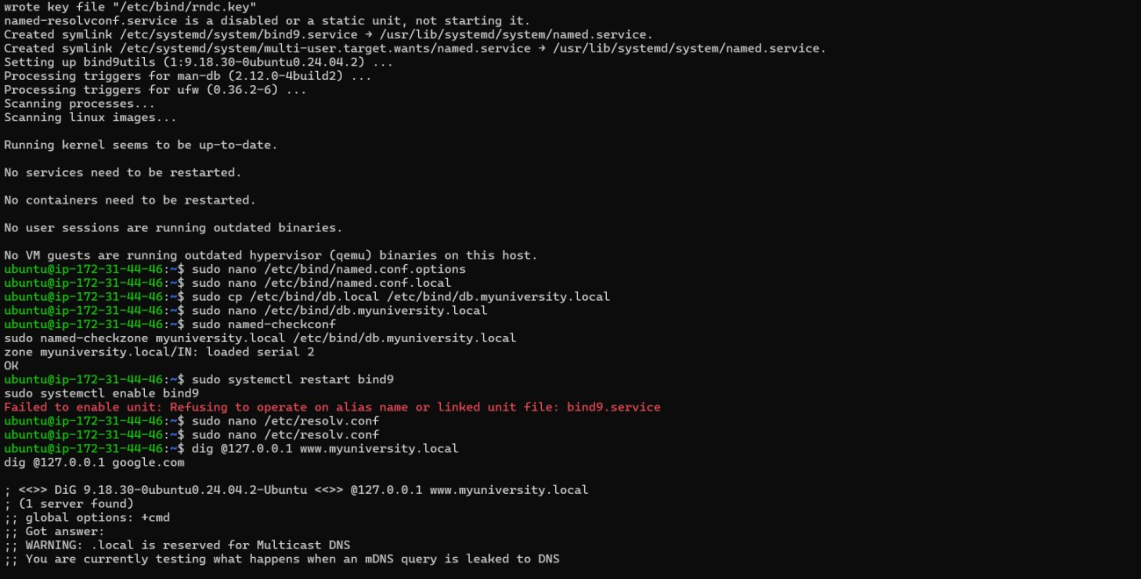

1. Install and configure ‘bind9’ as a local caching DNS server with a custom zone for’myuniversity,local’.



1. Configure SSH key-based login, disable password authentication, and disable root login in ‘sshd_config’.

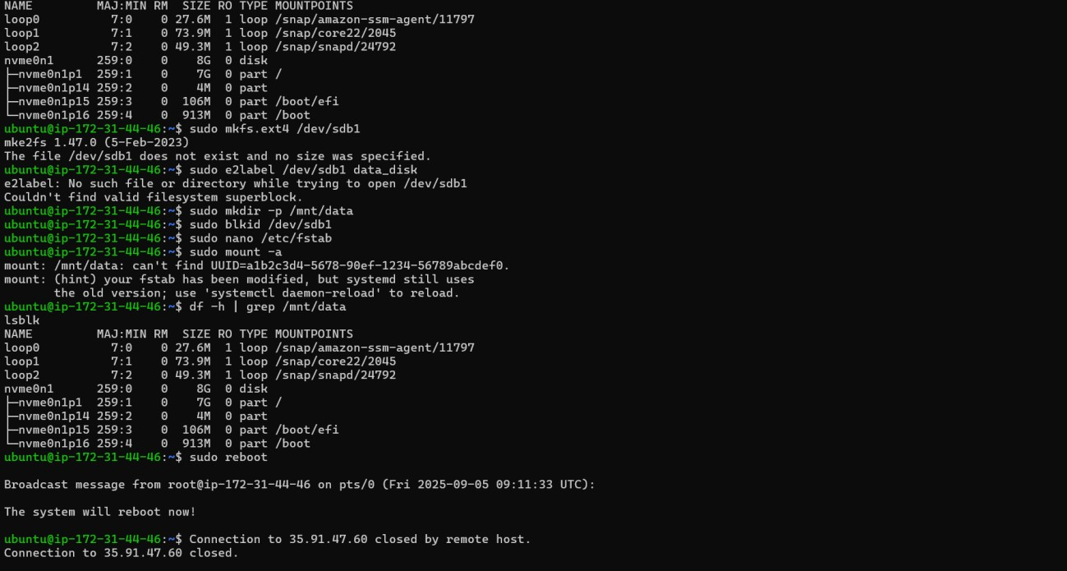

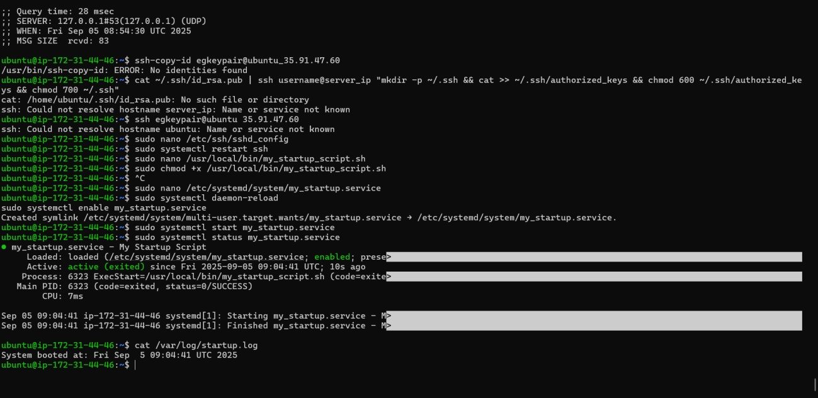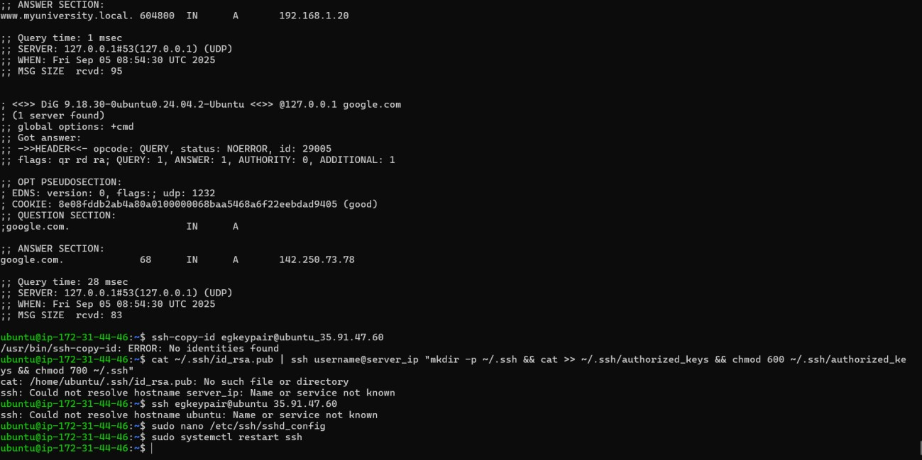

1. Write a simple script and create a ‘systemd’ service to run it automatically at boot.

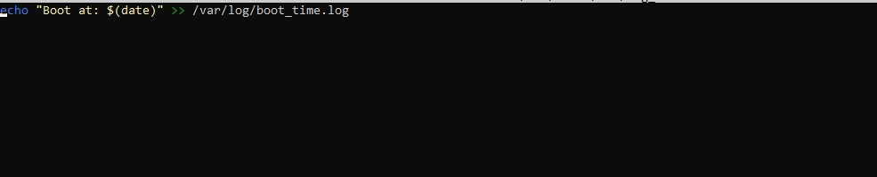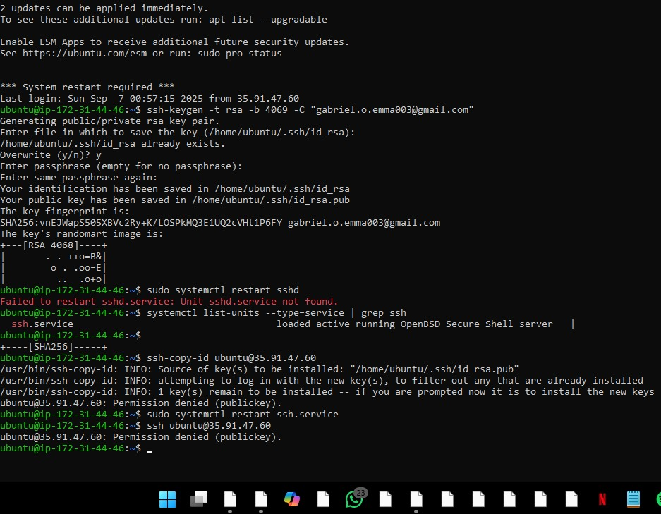

1. Create a new partition, format as ext4, mount it permanently using ‘/etc/fstab’, and test reboot persistance.



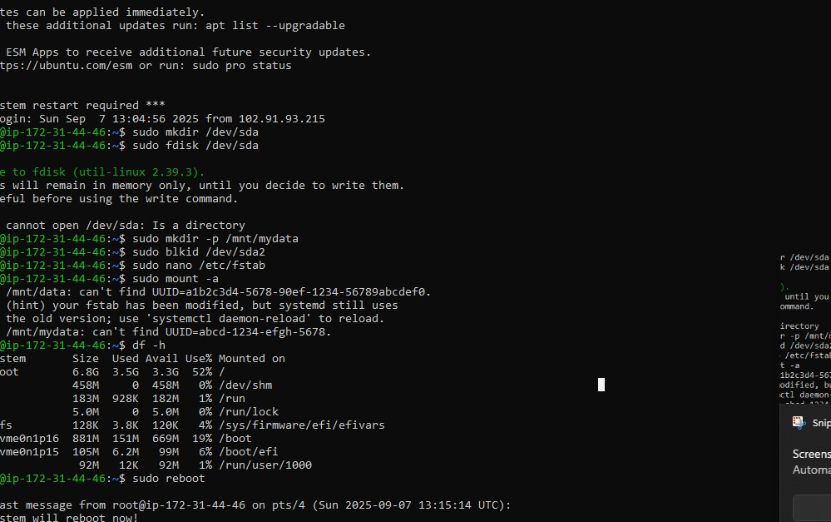

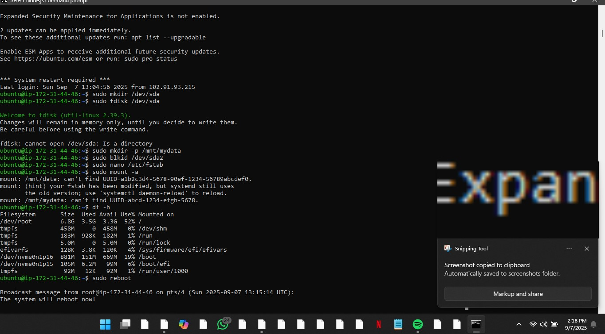

1. Install and configure postfix for local mail delivery and send a test mail between users.

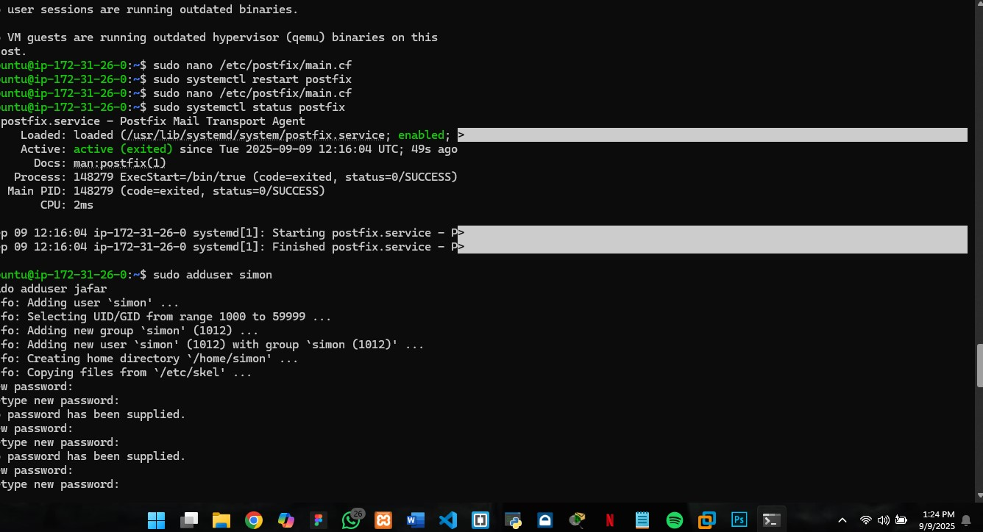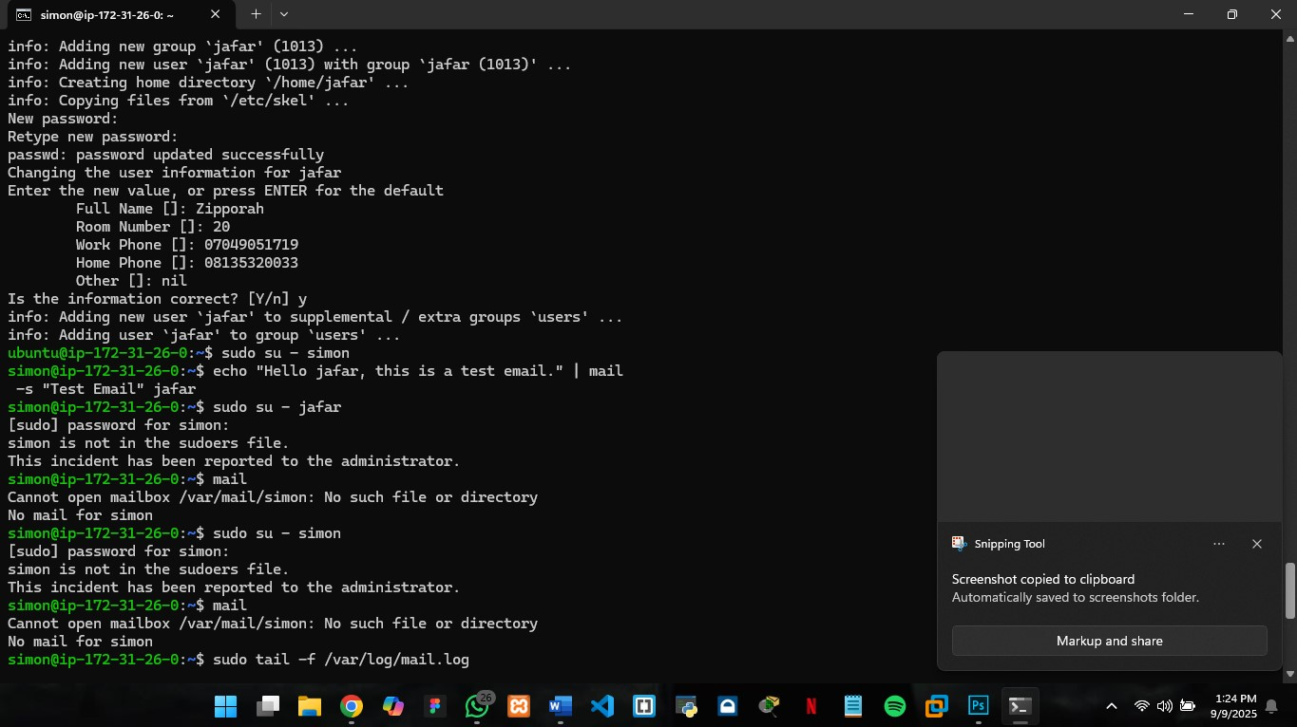

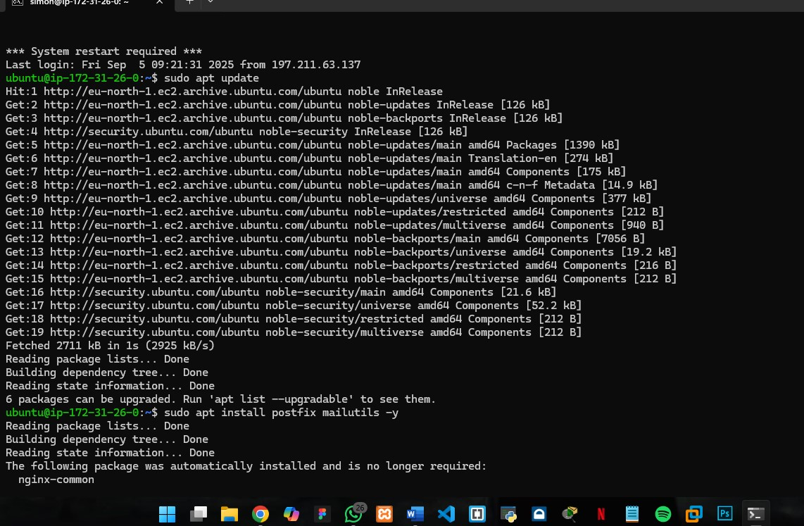

1. Write a script to back up ‘/var/www/html’ to ‘/backup/’ with a timestamp and test restoring.

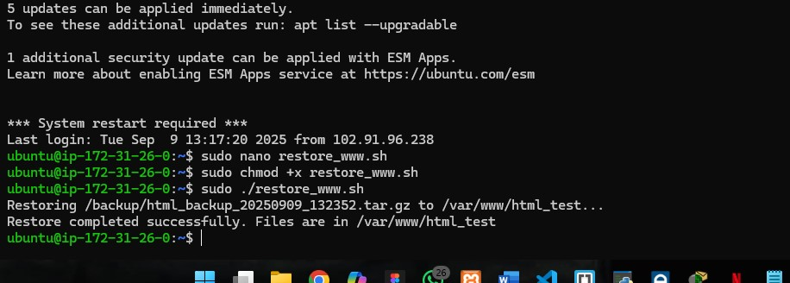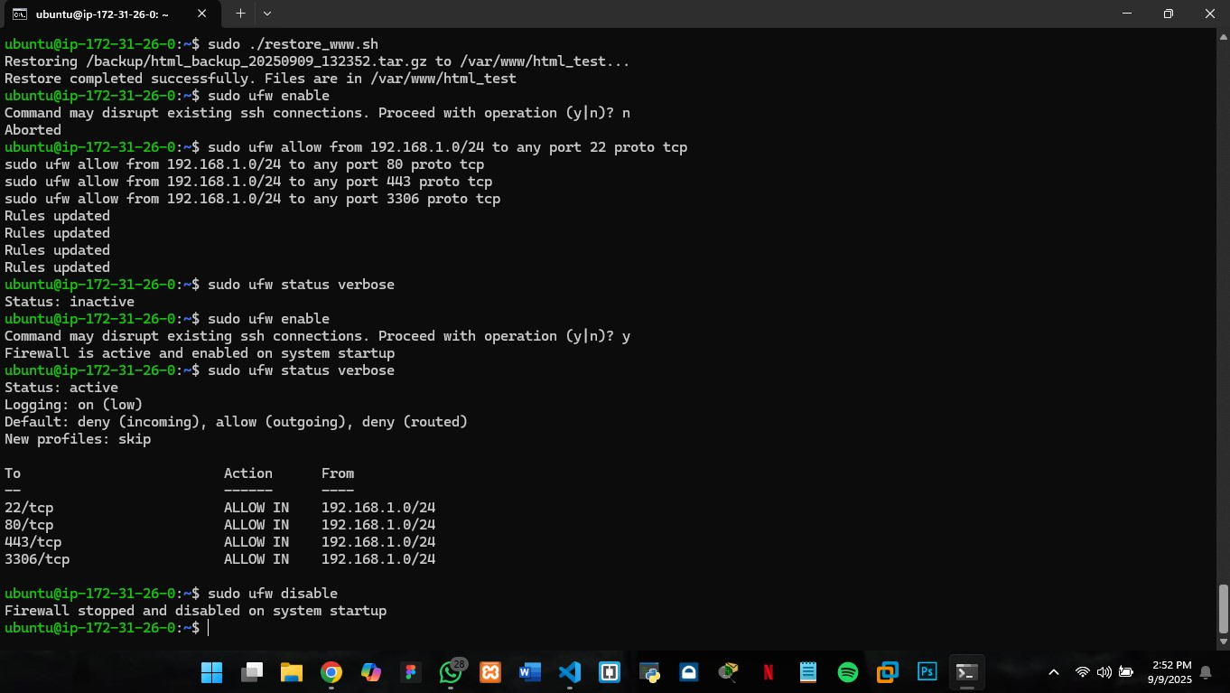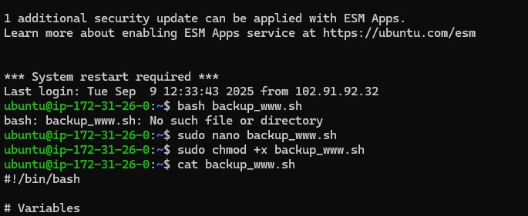

1. Install docker/podman, create a container running Nginx, map it to port 8080, and verify s



ervice.